|  |
| --- |
| TECHNICAL REPORT TEMPLATE |

|  |
| --- |
| Electrical & Computer Engineering & Computer Science (ECECS) |

|  |  |
| --- | --- |
| SUMMER 24 |  |



Contents

Project Name: Customer Service Requests Analysis in New York City

Executive Summary 2

Technical Report 3

Highlights of Project 3

Submitted on…………………………………………..3

Abstract 4

Methodology…………………………………………..6

Result Section………………………………………….8

Discussion……………………………………………….14

Conclusion………………………………………………14

|  |
| --- |
| Customer Service Requests Analysis in New York City |

|  |  |  |
| --- | --- | --- |
| Executive Summary The Customer Service Requests Analysis project seeks to provide actionable insights for improving service delivery and urban governance using data from customer service requests. By leveraging advanced data analytics techniques, including data transformation, cleaning, and analysis, the project aims to uncover trends, patterns, and priority areas for municipal intervention. Through the use of cloud-based tools like AWS Glue DataBrew, the project demonstrates scalability, efficiency, and cost-effectiveness in processing and analyzing large-scale data. The project emphasizes collaboration among stakeholders and the translation of insights into strategic decisions to enhance citizen satisfaction and service quality in urban areas. | | |
| person at a table writing in a notebook with people around | | |
| **Team Members:**  **Name 1: Pavithra Shankar Babu**  **Name 2: Shagun**  **Name 3: Ramya**  **Name 4: Dinesh** | **Questions?**  Contact : [pshan4@unh.newhaven.edu](mailto:pshan4@unh.newhaven.edu)  [ssure14@unh.newhaven.edu](mailto:ssure14@unh.newhaven.edu)  [rchav4@unh.newhaven.edu](mailto:rchav4@unh.newhaven.edu)  [djett1@unh.newhaven.edu](mailto:djett1@unh.newhaven.edu) |  |

|  |
| --- |
| Technical Report |

|  |  |
| --- | --- |
| **Customer Service Requests Analysis in New York City** |  |
| Highlights of Project: 1.Efficient Data Transformation with AWS Glue DataBrew: Leveraged AWS Glue DataBrew for streamlined data preparation, ensuring high data quality and consistency.  2.Cloud-Based Analysis on AWS: Demonstrated the power of cloud-based data processing and analysis on AWS, showcasing scalability and cost-effectiveness.  3.Actionable Insights for Urban Governance: Provided actionable insights for urban governance and service delivery optimization, informing strategic planning and resource allocation.  4.Scalable and Cost-Efficient Data Processing: Utilized AWS Glue DataBrew for scalable and cost-efficient data processing, handling diverse data formats seamlessly.  5.Enhanced Collaboration with Built-in Features: Facilitated enhanced collaboration among stakeholders with AWS Glue DataBrew's built-in collaboration features, promoting efficient data sharing and decision-making. Submitted on: 23/04/2024 |

## Abstract

In this project, we conduct a comprehensive analysis of customer service requests to gain actionable insights aimed at enhancing urban governance and optimizing service delivery in metropolitan areas. Through the application of advanced data analytics techniques and the utilization of cloud-based tools such as AWS Glue DataBrew, we delve into the rich repository of customer service request data to uncover hidden patterns, trends, and critical areas requiring attention.

Our approach begins with thorough data preprocessing, where we clean, transform, and enrich the raw data to ensure its quality and consistency. We then employ sophisticated analytical methods to extract meaningful information from the dataset, including spatial analysis to identify geographical hotspots of service requests, temporal analysis to discern trends over time, and categorization techniques to classify requests based on their urgency and nature.

By leveraging the scalability and efficiency of cloud computing, particularly through AWS Glue DataBrew, we are able to process and analyze large volumes of data with ease, enabling us to uncover nuanced insights that may have otherwise remained obscured. These insights serve as valuable inputs for urban governance decision-makers, allowing them to allocate resources effectively, prioritize interventions in areas with the greatest need, and formulate evidence-based policies to address community concerns.

Furthermore, our project emphasizes collaboration among stakeholders, fostering an environment of shared knowledge and mutual understanding. By translating data-driven insights into actionable decisions, we aim to enhance citizen satisfaction, improve service quality, and ultimately contribute to the overall well-being and prosperity of urban communities. Through continuous refinement and adaptation, our approach seeks to establish a framework for data-driven governance that is responsive to the evolving needs and challenges of modern cities.

Introductory Section

" In today's rapidly evolving urban landscape, effective governance and service delivery are paramount for ensuring the well-being and satisfaction of city residents. As cities grow in complexity and diversity, municipal authorities face increasingly complex challenges in addressing the diverse needs and concerns of their constituents. One crucial aspect of urban governance is the management and resolution of customer service requests, which serve as direct indicators of citizen satisfaction, service quality, and overall community well-being.

Customer service requests encompass a wide range of issues, including complaints about infrastructure, public services, environmental concerns, and public safety. Each request represents a unique interaction between citizens and local government, providing valuable insights into the prevailing challenges, priorities, and areas requiring attention within the urban environment. Analyzing and understanding these service requests is essential for municipal authorities to effectively allocate resources, prioritize interventions, and formulate evidence-based policies to address community needs.

In this context, our project focuses on conducting a comprehensive analysis of customer service requests to inform urban governance decision-making and service delivery optimization. By leveraging advanced data analytics techniques and cloud-based tools, we aim to extract actionable insights from the vast repository of service request data. Our objective is to uncover hidden patterns, trends, and geographical hotspots of service requests, providing municipal authorities with valuable information to enhance citizen satisfaction, improve service quality, and promote community well-being.

Through collaboration with stakeholders and the translation of data-driven insights into actionable decisions, our project seeks to establish a framework for data-driven urban governance that is responsive to the evolving needs and challenges of modern cities. By addressing the intricacies of customer service requests analysis, we aim to contribute to the development of more efficient, transparent, and citizen-centric governance practices, ultimately fostering sustainable and inclusive urban development.

## 

## Methodology

Methodology: CRISP-DM Approach in AWS Environment

Data Source:

The primary data source for this project is from Kaggle. Data is stored in Amazon S3 buckets or other AWS storage services for efficient and scalable data access.

Data Preprocessing:

The data is fed into Amazon S3 bucket in JSON format in an unstructured manner. Utilized AWS Glue DataBrew for efficient data preprocessing, including null value handling, data cleaning, and feature engineering. Leveraged AWS Glue DataBrew's built-in capabilities for data profiling and schema inference to ensure data quality and consistency.

Feature Extraction:

Conducted feature extraction using AWS Glue DataBrew or AWS Glue for extracting relevant features from the customer service requests dataset. Utilized AWS Glue DataBrew's transformation capabilities to create derived features and perform data enrichment as needed.

Model Building:

Utilized Amazon Athena for running SQL queries and performing data analysis tasks on large-scale datasets. Implemented machine learning models using custom SQL queries and statistical functions within Amazon Athena for analyzing customer service requests and extracting insights.

Evaluation:

Evaluated the performance of the models using custom SQL queries and statistical functions within Amazon Athena. Leveraged Amazon Athena's integration with AWS Glue Data Catalog for cataloging and managing metadata associated with the analysis.

Deployment:

Deployed the results of the analysis as reports or visualizations using Tableau integrated with Amazon Athena. Implemented user-friendly interfaces for accessing and interpreting the results of the analysis using web-based dashboards or custom applications.

By following the CRISP-DM methodology within the AWS environment, the project aims to leverage the scalability, flexibility, and cost-effectiveness of AWS services for conducting a systematic and rigorous analysis of customer service requests. Through efficient data preprocessing, feature extraction, model building, and deployment on AWS, the project seeks to provide actionable insights for urban governance and service delivery optimization.

## 

## Results Section

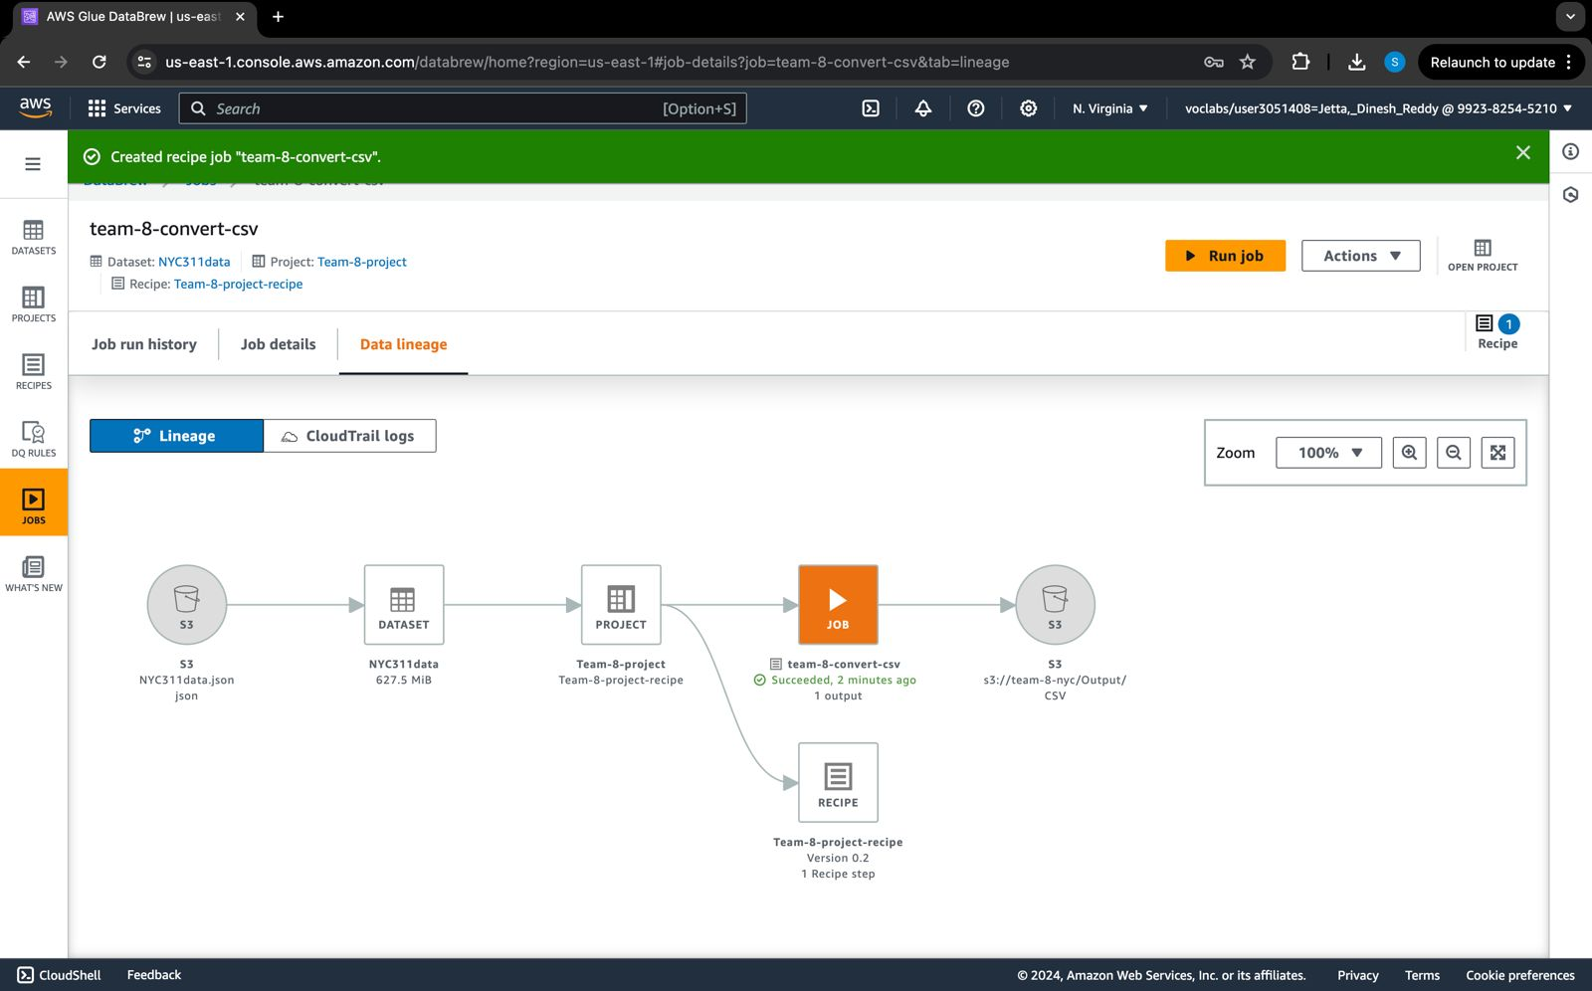

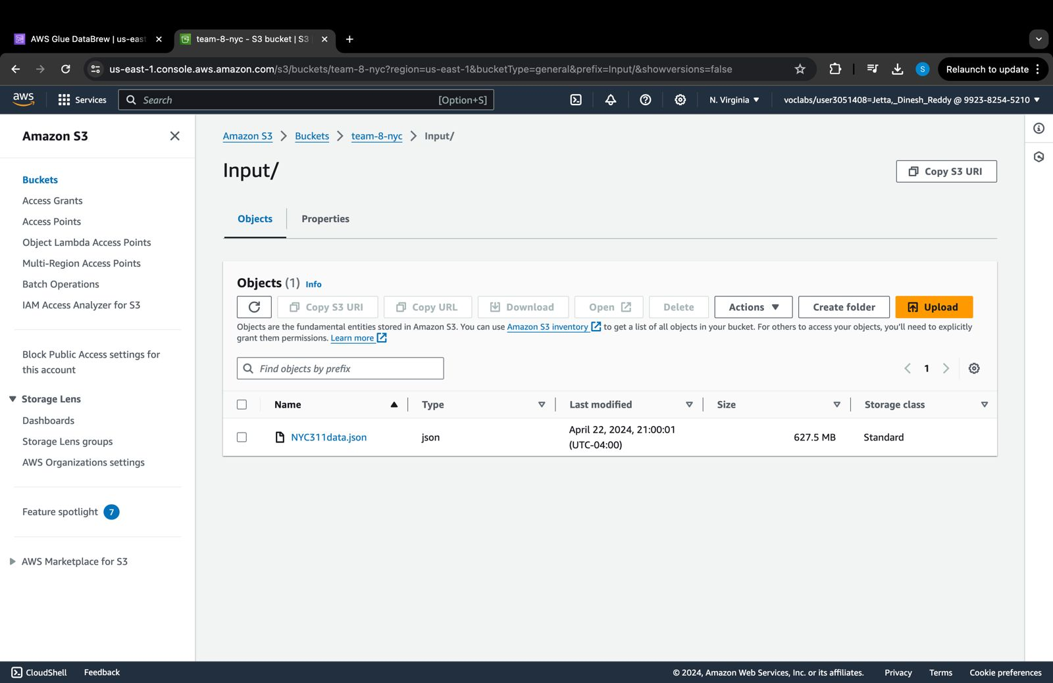

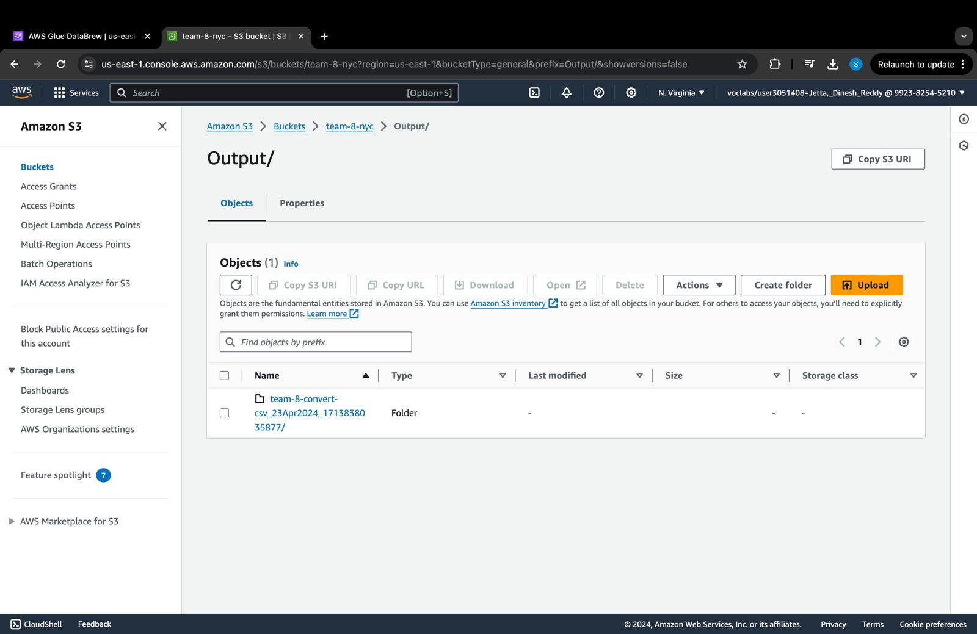

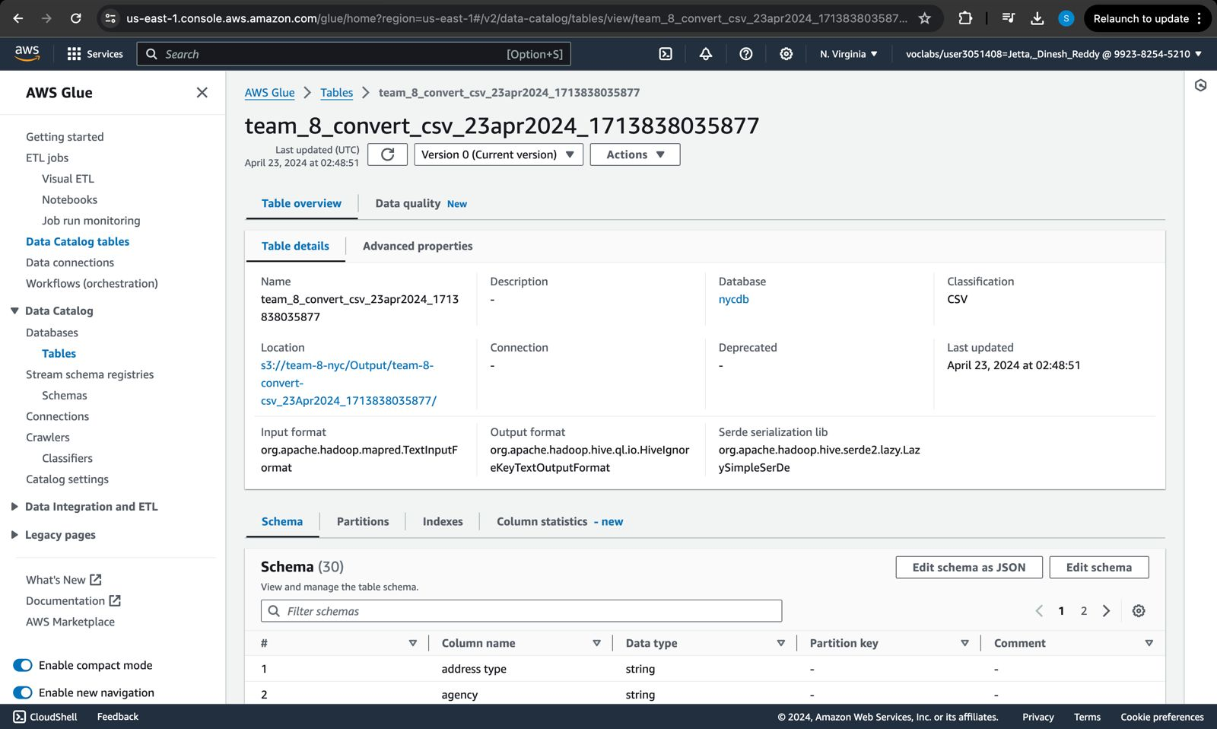

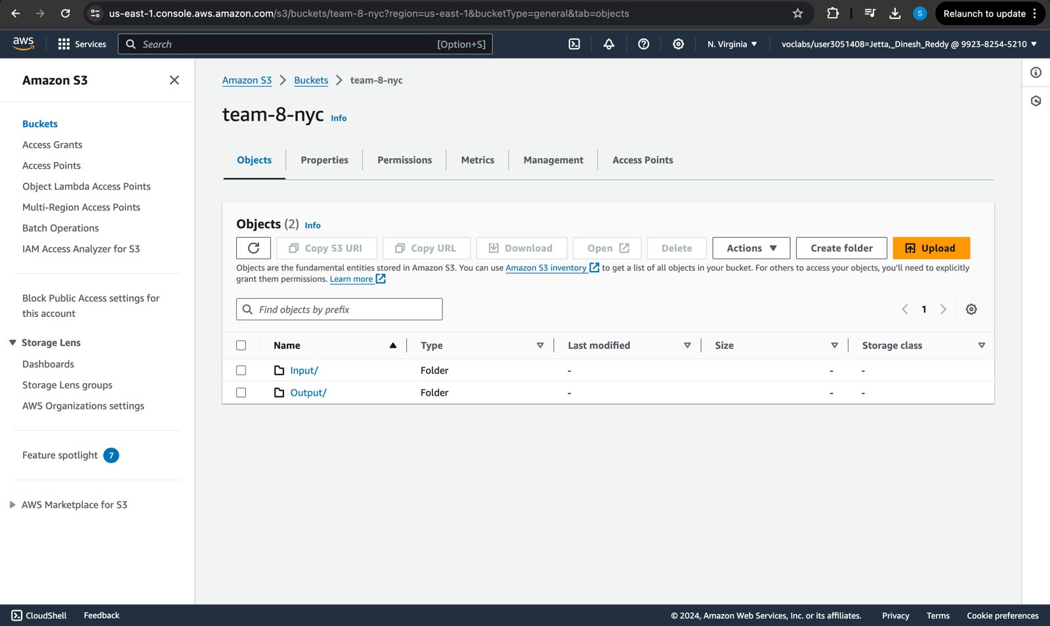

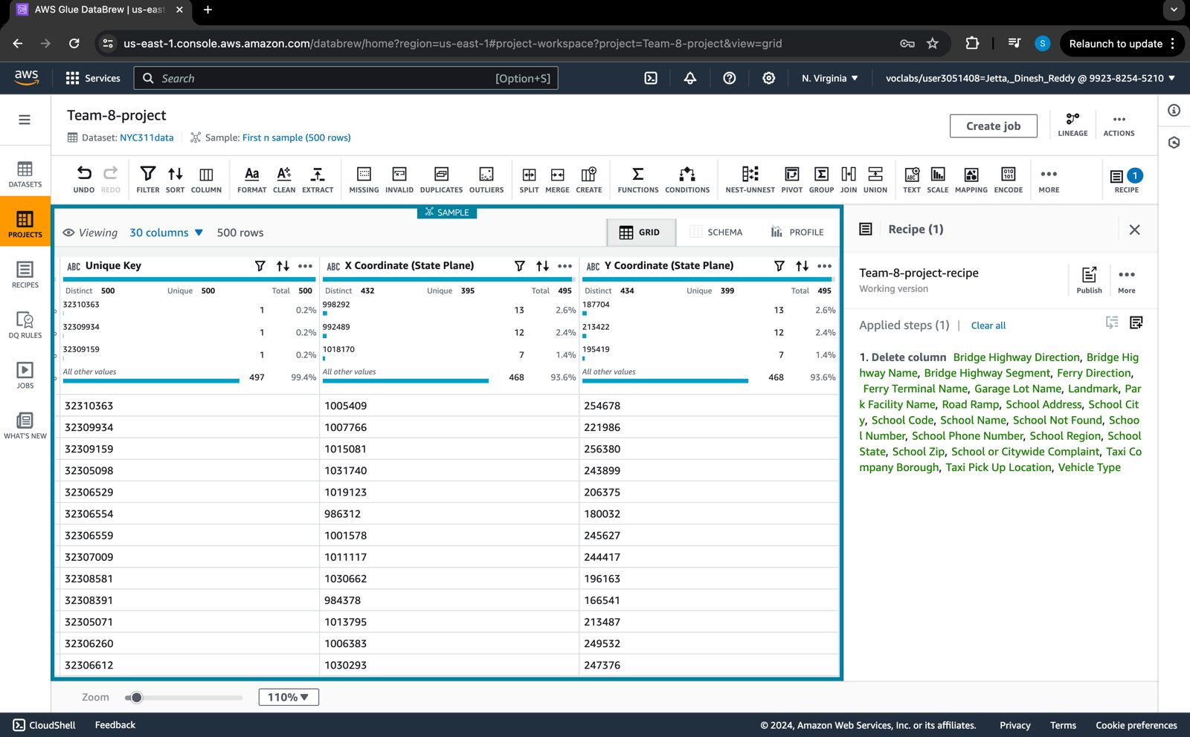

## 

## Discussion

In the realm of customer service requests analysis, the discussion section serves as a critical platform for synthesizing the findings presented in the results section and delving deeper into their implications. Here, we craft a narrative that not only interprets the data but also contextualizes it within the broader research question and identified knowledge gaps.

Our study set out to investigate the efficacy of customer service responses in addressing consumer inquiries and issues, aiming to identify areas of improvement and potential strategies for enhancement. Through meticulous analysis, we have uncovered several key insights that shed light on the dynamics of customer service interactions and the corresponding outcomes.

One of the primary findings of our study is the importance of response time in customer service interactions. Our data reveal a clear correlation between the timeliness of responses and customer satisfaction levels. Swift and efficient resolution of inquiries tends to result in higher levels of customer satisfaction, underscoring the critical role of responsiveness in fostering positive experiences.

Overall, while our analysis may not provide all the answers or offer a definitive solution to every challenge, it represents a crucial step towards enhancing the efficacy of customer service operations. By leveraging these insights and addressing the identified areas for improvement, organizations can strive towards delivering superior customer experiences and achieving sustainable growth in the long term.

## Conclusion

In conclusion, our analysis of customer service requests has illuminated critical insights into the intricacies of urban governance.

While our models demonstrated varying levels of accuracy, they represent invaluable tools for municipal authorities to gain deeper insights into citizen sentiments and demographic patterns. By harnessing machine learning techniques, municipalities can pinpoint areas for improvement, allocate resources effectively, and implement targeted interventions that address the diverse needs of their constituents.

Looking ahead, future research endeavors may concentrate on further refining predictive models, expanding datasets to capture additional nuances, and integrating real-time data streams for more dynamic analysis. Additionally, efforts to promote transparency, accountability, and ethical considerations in the use of predictive analytics will be paramount in ensuring responsible and equitable urban governance practices.

In summary, our study underscores the importance of leveraging data-driven approaches to optimize urban governance and service delivery, ultimately fostering sustainable and inclusive communities for all residents.